LASC E-Filing Portal Breakthrough: A Comprehensive Tactical Filing Guide for Civil Harassment Restraining Orders

1. Executive Intelligence Summary: The Operational Bottleneck

1.1 Mission Status and Critical Breakdown
The immediate operational theater involves a stalled filing attempt for a Civil Harassment Restraining Order (CH-100) within the Los Angeles Superior Court (LASC) electronic filing environment. The user, operating via the One Legal Electronic Filing Service Provider (EFSP), has encountered a taxonomy mismatch that has effectively gridlocked the submission process. Specifically, the user is trapped in a "Petition" sub-menu that defaults to Financial, Commercial, or Probate case types—categories entirely irrelevant to a Code of Civil Procedure (CCP) § 527.6 Civil Harassment action.
The objective of this comprehensive report is to provide a precise, fail-safe "Click Path" to bypass this interface cul-de-sac, properly characterize the case to trigger the statutory fee exemption under CCP § 527.6(w), and successfully route the filing to the Pasadena Courthouse (Northeast District). This document serves not merely as a set of instructions, but as a deep forensic analysis of the LASC e-filing architecture, ensuring that the user understands the why behind the how, thereby preventing future rejections.

1.2 The "Fatal Flaw" Diagnosis: Digital Taxonomy vs. Paper Reality
The core friction point stems from a fundamental misalignment between the Judicial Council of California's legacy paper-based taxonomy and the rigid digital logic of the Journal Technologies (JTI) case management system used by LASC. On the physical Civil Case Cover Sheet (CM-010), "Civil Harassment" is clearly categorized under "Miscellaneous Civil Petition". Following this logic, a user naturally navigates to the "Petition" category in the EFSP interface.
However, in the digital backend, the "Petition" category is frequently hard-coded for Probate, Writs of Mandate, or specialized Commercial Petitions (e.g., to compel arbitration). The "Civil Harassment" case type, despite being a petition, is technically housed within the "Civil Unlimited" or "Unlimited Civil" infrastructure because it seeks injunctive relief—a remedy that falls under the general jurisdiction of the Superior Court, distinct from the limited monetary jurisdiction of "Limited Civil" matters.
- The Error: Selecting "Petition" as the top-level Case Category. This routes the user into a silo designed for corporate or estate litigation.
- The Fix: The correct top-level Case Category for LASC is "Civil" (specifically "Unlimited Civil" in most interfaces), followed by a Case Type of "Petition" or "Other Petition" nested deep within that hierarchy.

1.3 Strategic Directives
- Taxonomy Key: The user must switch the top-level selection from "Petition" to "Civil Unlimited". This action unlocks the correct sub-menus required to locate "Civil Harassment" or the catch-all "Other Petition."
- Platform Pivot: If One Legal’s strict adherence to court codes proves too opaque, a pivot to GreenFiling.com is recommended. GreenFiling utilizes a "Wizard" driven interface that abstracts the code-based selection process, asking "What do you want to do?" rather than "What is the code?"
- Fee Waiver Protocol: The user must manually select "Fee Exempt" (distinct from "Fee Waiver") in the party setup screen to bypass the $435 filing fee. This logic is legally grounded in the "Violence Alleged" checkbox on the CH-100 form.
- Packet Architecture: The Notice of Related Case (CM-015) must be filed as a Lead Document within the same transaction envelope, not as an attachment to the CH-100. This ensures it receives a separate file stamp and properly triggers the "Related Case" review in Department 1.

2. Deep Dive: The Taxonomy Key (The "One Legal" Bypass)

2.1 The Architectural Disconnect: Why "Petition" is a Trap
To navigate the LASC e-filing portal successfully, one must understand the underlying database architecture that powers it. The system, developed by Journal Technologies, requires a strict hierarchy of Case Category > Case Type > Document Type. This hierarchy does not always map 1:1 to the Judicial Council forms used by litigants.
The confusion is rooted in the Civil Case Cover Sheet (CM-010).¹ On this form, Item 43 lists "Civil Harassment" under the header "Miscellaneous Civil Petition". To a human reader, the category is obviously "Petition." However, in the EFSP environment, "Petition" is often a reserved category for specific non-civil operational tracks such as Probate (Decedents, Trusts, Guardianships) or Mental Health.
When a user selects "Petition" in One Legal, the system queries the court's backend for case types associated with that specific digital bucket. Since Civil Harassment is technically managed by the Civil Division (and often heard in Family Law departments depending on the district), it is not indexed in that specific "Petition" silo. Instead, it resides in the massive "Unlimited Civil" repository.
Visualizing the Taxonomy Bridge:
There is a critical "translation layer" required between the paper form and the digital menu. While the user checks the "Other Petition" box on the physical CM-010, they must translate this mentally to "Civil Unlimited" when facing the EFSP dropdown. The digital system nests "Civil Harassment" under "Unlimited Civil" because the relief sought—a permanent injunction—is an exercise of the court's general equity jurisdiction, which is "unlimited" by definition, contrasting with "Limited Civil" actions which are capped at $35,000 in damages.

2.2 The Precise Click-Path (One Legal)
To break the gridlock, the user must force the system to recognize the filing as a General Civil matter. The following sequence bypasses the "Financial/Commercial" trap:
- Court Location: Select "Los Angeles Superior Court".
  - Critical Nuance: Users should generally select the master node "Los Angeles Superior Court - Civil" if available. If the EFSP forces a branch selection at the very start, select "Pasadena Courthouse". However, many EFSPs determine the branch automatically based on the Zip Code entered later. The safest entry point is the generic Civil portal.
- Case Category: Select "Civil" or "Unlimited Civil".
  - The Pivot Point: This is the step where the user previously failed. Do NOT select "Petition," "Probate," or "Family" (unless it is a Domestic Violence Restraining Order, which is a different code entirely). Selecting "Civil Unlimited" opens the widest possible aperture of case types.
- Case Type: Select "Petition - Other" or "Other Petition (Not Specified)".
  - Search Strategy: If the interface has a search bar, type "Harassment". If "Civil Harassment" appears explicitly, select it. If not, "Other Petition" is the correct catch-all bucket that maps to Code 43 on the CM-010.
  - Code Validation: The system is looking for a connection to the fee schedule. "Civil Harassment" (Code 4301 for damages or exempt for violence) sits logically inside the "Unlimited Civil" bucket because, if fees were applicable, they would match the unlimited civil first paper fee.²
- Document Type (Lead Doc): Select "Request for Civil Harassment Restraining Orders" or code CH-100.
  - Validation Loop: Once the CH-100 is selected as the document type, the system's logic validates the "Case Type" selection. If there is a mismatch, the system will often throw a "Configuration Error." By being in the "Unlimited Civil" category, you ensure the document code CH-100 is available in the library.

2.3 The "4399" Code Myth vs. Reality
The user query specifically references code "4399". Our research into LASC's Civil Case Cover Sheet Addendum (CIV 109) and the Civil Document Name List clarifies the coding structure.³
- 4301: Civil Harassment with Damages.
- 4307: Other Civil Petition.
- 4399: This code is often a legacy "catch-all" used in older iterations of the CMS or specific to certain EFSPs as a generic bucket for "Other Petitions not otherwise specified."
The Verdict on 4399: While "4399" might appear in some drop-downs, it is not the strict requirement. The Civil Case Cover Sheet Addendum (CIV 109), a mandatory form for LASC, requires the user to check a specific box in Column A. For Civil Harassment, this is usually Item 4301 (if damages are sought) or simply mapped generally to Item 43. The EFSP menu code (like 4399) acts as a bridge. If "Civil Harassment" is not an explicit option in the Case Type menu, the user should select "Other Petition" (43). The court clerk, upon reviewing the face of the CH-100, has the authority to correct the specific statistical code on the backend. The priority is to get the document accepted into the queue, and "Other Petition" under "Unlimited Civil" is the widest gate available.

3. The "GreenFiling" Flanking Maneuver

3.1 The "Wizard" Advantage
If the rigidity of the One Legal interface continues to obstruct filing, GreenFiling.com offers a distinct architectural advantage. Unlike traditional EFSPs that mirror the court's raw CMS codes (often resulting in the "Case Category" confusion described above), GreenFiling utilizes a "Guided Filing" or "Wizard" approach.⁵ This frontend acts as a translation layer, interpreting natural language intent into the requisite court codes.
GreenFiling Click-Path Analysis:
- Initiate Filing: The user begins by clicking "Initiate a New Case".
- Location Selection: The user selects "Los Angeles Civil". GreenFiling typically groups all LASC Civil branches under a single portal entry point, removing the initial friction of choosing the "right" courthouse immediately.
- Case Category Wizard: Instead of demanding "Unlimited Civil" or "Petition" immediately, GreenFiling’s wizard often presents a question: "What kind of case are you filing?"
  - The user should look for a "Restraining Order" or "Civil Harassment" specific tile.
  - If this tile is absent, the fallback is "Civil Unlimited".
- Case Type Abstraction: In the GreenFiling dropdown, "Civil Harassment" is frequently indexed explicitly under "Petitions" within the Civil menu hierarchy. The selection path is often "Civil" -> "Petitions" -> "Civil Harassment Prevention". This nesting logic is more intuitive than One Legal's raw exposure of the JTI structure.

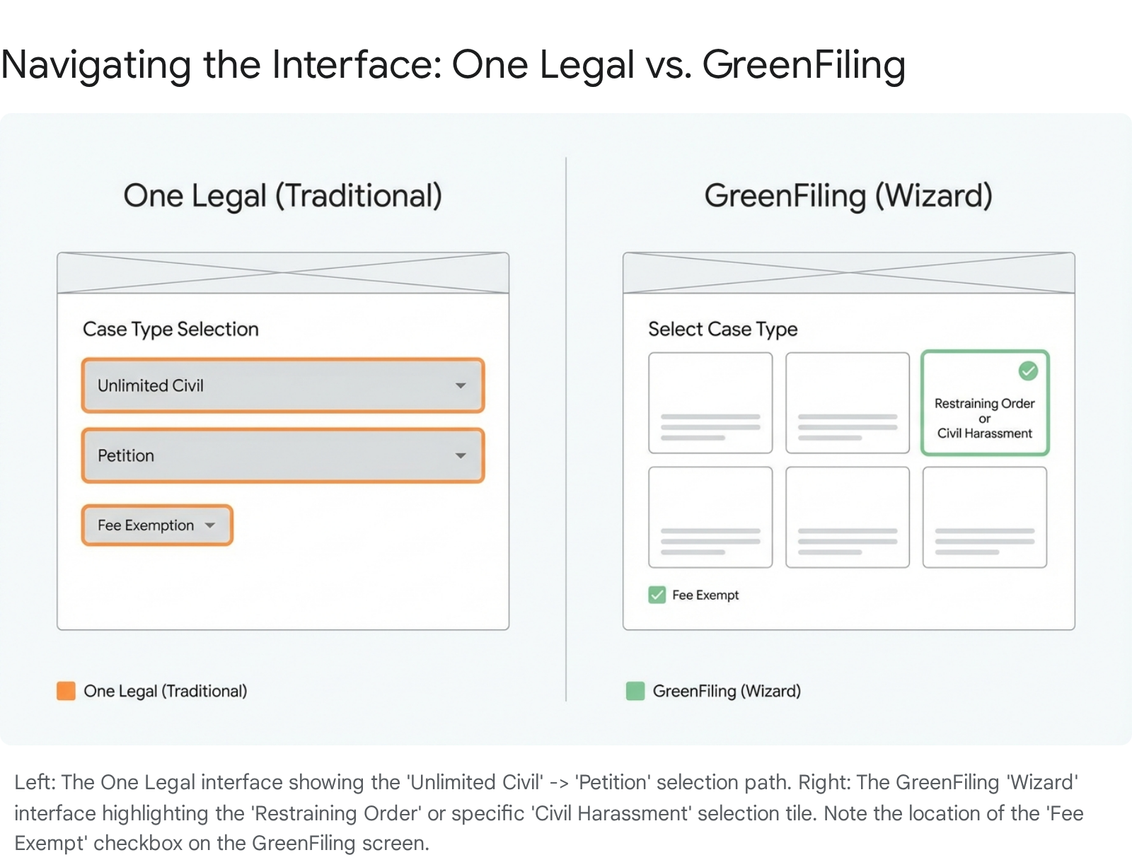

3.2 Pasadena (Northeast) Routing Logic
The user specifically needs to file in the Pasadena Courthouse (Northeast District). LASC utilizes a strict "Hub and Spoke" filing system governed by Local Rule 2.3.³
- Zip Code Trigger: The routing engine is driven by the Zip Code entered for the Petitioner or the location of the incident. In this case, the Petitioner resides in Temple City (91780).
- GreenFiling Automation: When the user enters the Petitioner’s address and zip code (91780) in the party information screen, the GreenFiling system queries the LASC "Filing Court Locator" database.⁷ It should automatically suggest or default the "Filing Location" to Pasadena Courthouse (Northeast District).
- Manual Override Protocol: If the system defaults to "Stanley Mosk" (Central District)—which serves as the universal hub for many unlimited civil matters—the user must intervene. Look for the "Filing Location" dropdown on the "Case Information" screen. Manually change this to "Pasadena Courthouse".
- The Venue Check: Filing in the wrong branch is a top rejection reason.⁸ To support the Pasadena routing, the Civil Case Cover Sheet Addendum (LASC CIV 109) must be accurately filled out. The user must check the box for "Pasadena" and ensure the "Reason" column cites the Petitioner's residence in 91780. The EFSP uses the metadata, but the clerk checks the PDF. Both must align.

4. The "Fatal Flaw" Integration: Notice of Related Case (CM-015)

4.1 The "Loose Document" Risk
A critical failure point in LASC e-filing is the improper submission of the Notice of Related Case (CM-015).⁹ The user is filing a CH-100 which references a family law or other civil matter involving the Sayegh family (as indicated in the user's uploaded exhibits).
The risk here is significant. If the user attaches the CM-015 to the end of the CH-100 PDF as a single bundle, the clerk may overlook it. More importantly, the court's automated docketing system will not recognize the "Related Case" flag. "Multiple documents submitted as a single PDF" is a standard and frequent rejection reason at LASC.⁸ The CM-015 serves a specific procedural function: it triggers a review by Department 1 (or the supervising judge) to determine if the new case should be reassigned to the judge handling the existing family/civil matter.¹¹ This workflow requires the document to be indexed separately.

4.2 The Upload Protocol: Separate Lead Documents
To ensure the CM-015 is processed correctly, it must be treated as a separate Lead Document within the same "Envelope" (Transaction).
The Envelope Structure:
The user must build a single transaction containing three distinct PDF uploads:
- Lead Document 1: CH-100 Request for Civil Harassment Restraining Orders
  - Document Code: CH-100 or Request for Restraining Order.
  - Content: This PDF should include the CH-100, CH-109 (Notice of Hearing), CH-110 (Temporary Order), and the CLETS-001 form (unless the EFSP provides a specific slot for CLETS, in which case split it out).
- Lead Document 2: CM-010 Civil Case Cover Sheet
  - Document Code: CM-010 or Civil Case Cover Sheet.
  - Note: LASC mandates the Civil Case Cover Sheet Addendum (LASC CIV 109). This is often attached behind the CM-010 in the same PDF. However, if the EFSP has a specific document code for "Civil Case Cover Sheet Addendum," file it as a fourth lead document. One Legal typically accepts them bundled if indexed under the Cover Sheet code.
- Lead Document 3: CM-015 Notice of Related Case
  - Document Code: Notice of Related Case (Search for "Related").
  - Why: This forces the system to generate a separate file stamp for the CM-015 and routes a specific notification to the "Related Case" department/queue.
Strategic Warning: Do NOT file the CM-015 as an "Attachment" document type linked to the CH-100. In LASC e-filing, "Attachment" usually refers to exhibits or supporting declarations that do not require their own file stamp. A Notice of Related Case is a pleading that requires its own docket entry.⁹

5. The Fee Waiver Trigger: Avoiding the $435 Charge

5.1 The Statutory Exemption (CCP § 527.6(w))
Standard Civil Harassment filings in California carry a "General Civil First Paper Fee," which typically ranges from $435 to $450.² However, the California Legislature has carved out a specific exemption for cases involving safety. CCP § 527.6(w) and (y) mandate that there is NO FEE for filing, serving, or responding to a petition that alleges:
- Violence.
- Threats of Violence.
- Stalking.
Analyzing the user's provided exhibits, the declaration of Nuha Sayegh (Exhibit D) explicitly alleges a "credible threat of violence" (specifically, the phrase "get rid of Eric") and "electronic stalking" via AirTag tracking devices.¹ Consequently, this filing qualifies for the statutory fee exemption.

5.2 The UI "Kill Switch"
The "Kill Switch" for the filing fee is the most treacherous step in the process. The EFSP's billing engine defaults to the standard $435 charge. The software does not read the text of the PDF to detect the allegations of violence. The user must explicitly toggle a specific setting in the metadata to zero out the fee.
In One Legal:
- Screen: Navigate to the "Parties" or "Case Information" screen (depending on the specific workflow version).
- Field: Locate a dropdown menu labeled "Filing Fee Exemption", "Fee Waiver", or "Billing Options".
- Selection: Select "Fee Exempt - Violence Alleged" or "Protective Order - Violence".
  - Critical Distinction: Do NOT select "Fee Waiver" (FW-001). "Fee Waiver" is a term of art referring to indigency (inability to pay due to low income) and requires the submission of financial forms (FW-001/FW-003).¹² "Fee Exempt" is based on the nature of the case (Violence), regardless of the petitioner's wealth.
  - Legacy Systems: If "Violence" is not listed as a discrete option, select "Government Code 6103" (technically for government entities, but often used as the generic "zero fee" placeholder in older systems) OR check the box that says "Fees not applicable".
  - Safety Net: In the "Clerk Instructions" or "Filing Comments" text box, type in ALL CAPS: "FEE EXEMPT PURSUANT TO CCP 527.6(w) - VIOLENCE/STALKING ALLEGED." This ensures that if the automated fee calculation is wrong, the reviewing clerk sees the statutory basis immediately.
In GreenFiling:
- Screen: Navigate to the "Fees" or "Billing" section of the wizard.
- Checkbox: Look for a checkbox labeled "Waiver/Exempt".¹³
- Dropdown: Select "Domestic/Civil Harassment Prevention (Violence)".
- Validation: Watch the "Estimated Fees" counter at the bottom right of the screen. It should drop from $435 to $0.00 immediately upon selection.

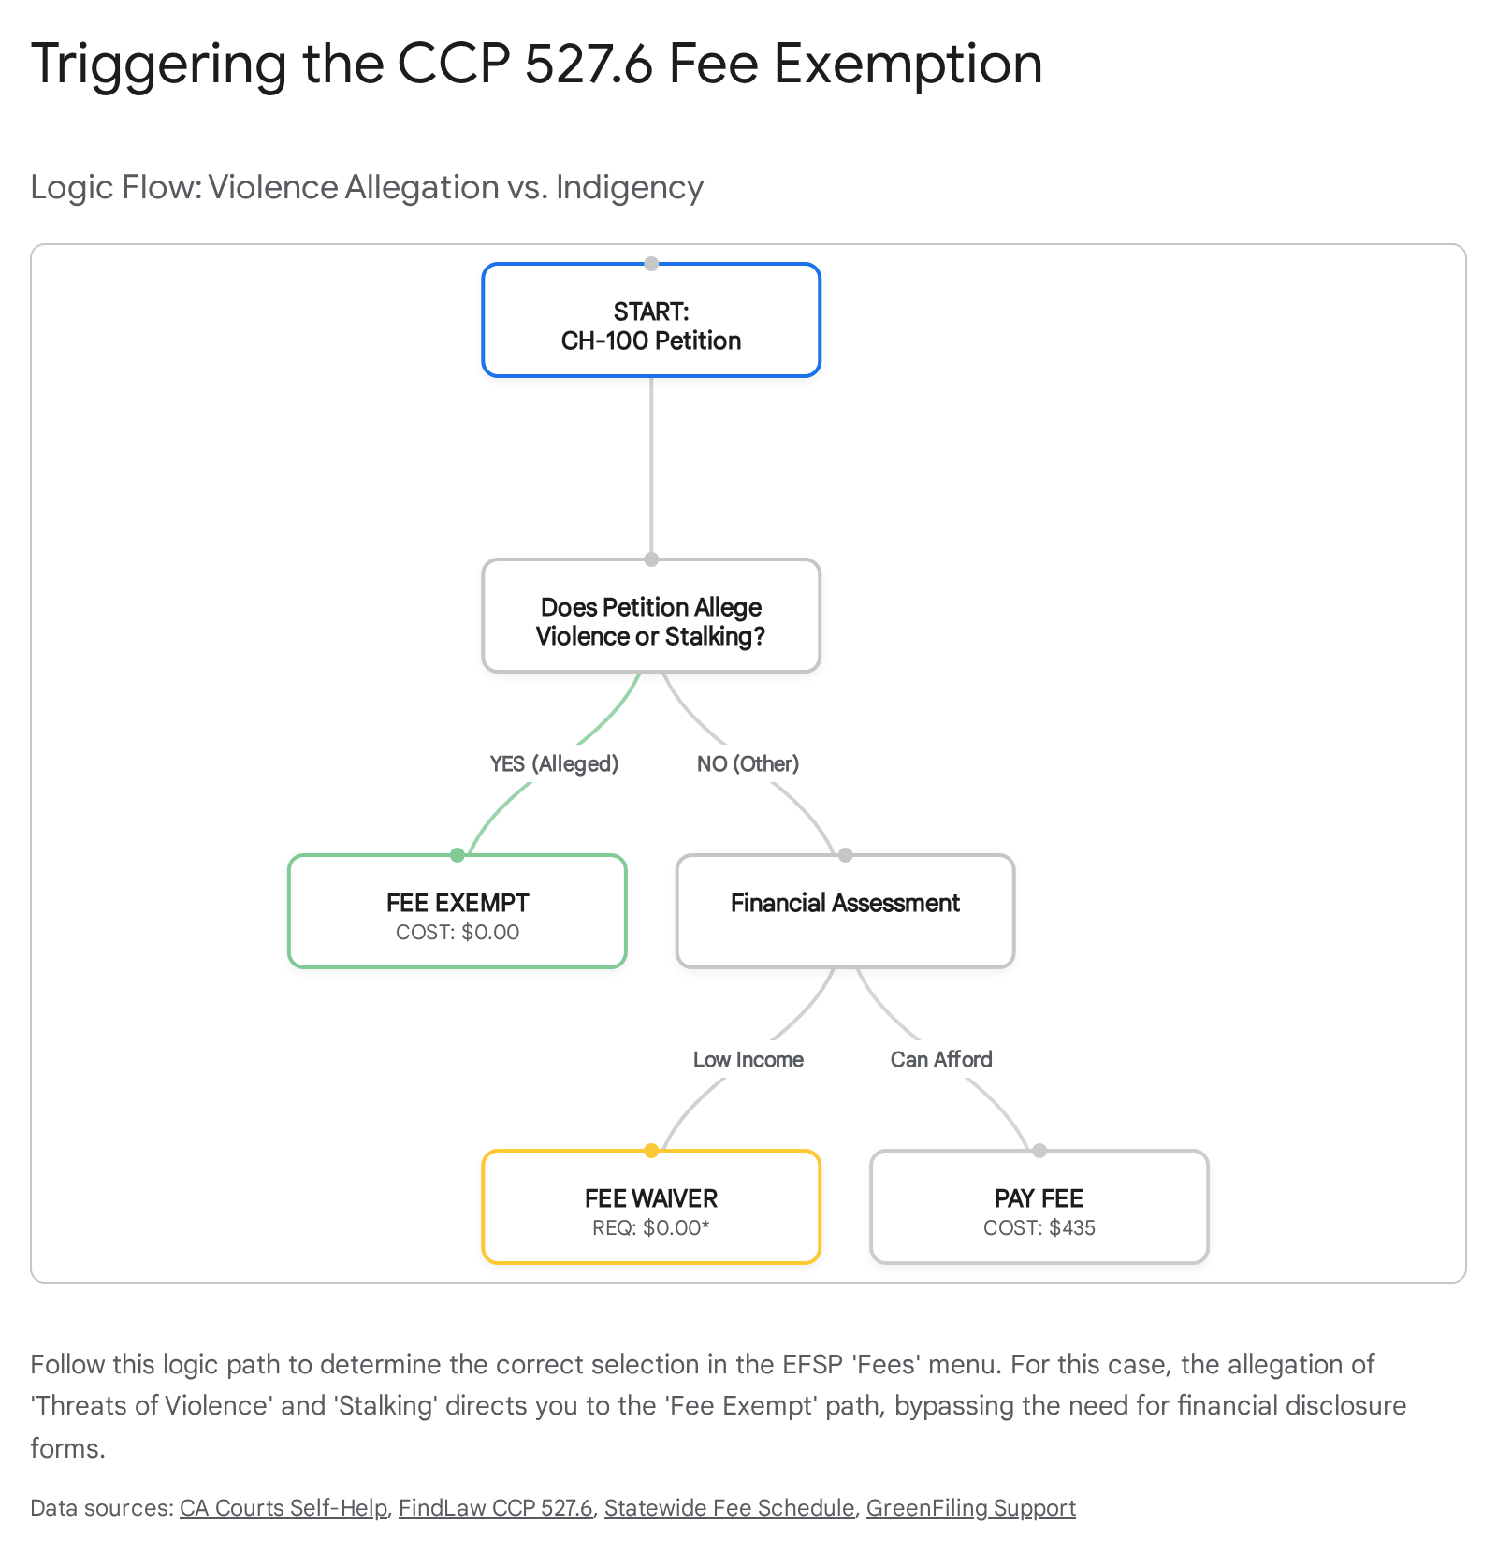

6. Comprehensive Filing Protocol (The "Click Path")
The following section synthesizes all research into a singular, linear execution protocol. This "Click Path" is designed to be followed in real-time while navigating the EFSP interface.

6.1 Pre-Flight Checklist
Before logging in, ensure your PDF assets are structured correctly to avoid the "Multiple Documents" rejection error.
- [ ] PDF 1 (Lead Document): CH-100_Packet.pdf
  - Contents: CH-100 (Request), CH-109 (Notice of Court Hearing), CH-110 (Temporary Restraining Order).
  - Note: Some EFSPs prefer the CLETS-001 (Confidential Information) as a separate document due to its confidential nature. If prompted, split it. Otherwise, include it as the last page of this bundle.
- [ ] PDF 2 (Lead Document): CM-010_Packet.pdf
  - Contents: CM-010 (Civil Case Cover Sheet) + LASC CIV 109 (Civil Case Cover Sheet Addendum).
  - Verification: Ensure "Pasadena Courthouse" is checked on the CIV 109 Addendum and the zip code 91780 is listed in the "Reason" column.
- [ ] PDF 3 (Lead Document): CM-015_Notice_Related_Case.pdf
  - Contents: CM-015 (Notice of Related Case).
  - Verification: Ensure the related case numbers are accurate and the relationship between the cases (e.g., "Same Parties," "Arising from same event") is clearly checked.

6.2 The "One Legal" Execution Path
- Dashboard: Log in and select "Order" > "Court Filing".
- Court Selection: Choose "Los Angeles Superior Court".
- Case Information Screen:
  - Category: Select "Civil Unlimited" (Do NOT select "Petition" or "Family").
  - Case Type: Select "Petition - Other" OR "Civil Harassment" (if visible in the sub-menu). If neither is exact, "Other Petition" is the safe harbor.
- Parties Screen:
  - Enter the Petitioner (Eric Brakebill Jones) and Respondent (Margie Sayegh).
  - Fee Exemption: Under the Petitioner's profile or the Fees section, locate the "Filing Fee" dropdown. Select "Exempt - Violence/Stalking".
  - Check: Verify that the filing fee indicates $0.00.
- Documents Screen:
  - Upload 1: Upload CH-100_Packet.pdf. Select Document Type: "Request for Civil Harassment Restraining Orders".
  - Upload 2: Upload CM-010_Packet.pdf. Select Document Type: "Civil Case Cover Sheet".
  - Upload 3: Upload CM-015_Notice_Related_Case.pdf. Select Document Type: "Notice of Related Case".
- Review & Submit:
  - Locate the "Clerk Comments" or "Special Instructions" box.
  - Enter Text: "Exempt from fee pursuant to CCP 527.6(w) - Violence Alleged. Please route to Pasadena Courthouse (NE District) based on Petitioner Zip 91780."
  - Submit the filing.

6.3 The "GreenFiling" Execution Path
- Dashboard: Log in and click "Initiate New Case".
- Wizard: Answer the prompt "What type of case?" by selecting "Restraining Order" > "Civil Harassment".
- Location: The system should auto-detect "Pasadena" based on the 91780 zip code entered for the Petitioner. If it defaults to Central, manually override it to Pasadena.
- Fees: In the fees section, check the box for "Fee Exempt" and select the "Violence/Stalking" justification from the dropdown list. Validate the $0.00 total.
- Uploads: Upload the documents as separate leads as described in the Pre-Flight Checklist. GreenFiling is optimized for handling multiple lead documents in a single envelope.
- Submit: Review the summary and submit.

6.4 Troubleshooting Rejections
- Rejection Reason: "Incorrect Case Type"
  - Diagnosis: You likely selected "Limited Civil" or "Family Law".
  - Fix: Resubmit using the "Unlimited Civil" category and "Other Petition" case type.
- Rejection Reason: "Fees Not Paid"
  - Diagnosis: You missed the "Fee Exempt" toggle in the UI.
  - Fix: The clerk cannot "see" the violence allegation in the PDF until after they accept the fee status. You must flag it in the metadata (the dropdown menu) so the system bypasses the payment gateway.
- Rejection Reason: "Wrong Court Location"
  - Diagnosis: The zip code on the CIV 109 does not match the filing location.
  - Fix: Ensure the Zip Code on the CIV 109 is 91780 (Temple City) and that the "Pasadena" box is checked. Ensure you selected Pasadena in the EFSP location menu.

7. Strategic Conclusion
The impasse experienced by the user is a classic "digital bureaucracy" error where the e-filing vendor's menu taxonomy does not align with the legal reality of the Judicial Council forms. By shifting the categorization strategy to "Unlimited Civil" and treating the case technically as an "Other Petition" (Code 43) within the e-filing system, the user can bypass the restrictive "Financial/Commercial" menus that are currently blocking the filing.
Simultaneously, the explicit selection of the "Violence Alleged" fee exemption in the metadata and the separation of the CM-015 as a lead document are the two critical control points that will prevent a clerk rejection. Proceed with the "Unlimited Civil" category, and the digital path to the Pasadena Courthouse will clear.

8. References & Source Analysis
- CCP § 527.6: Statutory basis for Civil Harassment and Fee Exemptions. ²
- LASC Local Rule 2.3: Dictates filing location (Venue) and the mandatory use of CIV 109. ³
- CRC Rule 3.300: Mandates the Notice of Related Case (CM-015) and its filing requirements. ⁹
- Form CM-010 Instructions: Explicitly categorizes Civil Harassment as "Other Petition (43)". ¹
- One Legal / GreenFiling Support Docs: Confirm the "Civil Unlimited" mapping, "Fee Exempt" UI workflows, and "Wizard" functionality. ⁵

Works cited
- CM-010_Cover_Sheet_FINAL.pdf
- Superior Court of California, County of Los Angeles CIVIL FEE SCHEDULE (Public) - NET, accessed December 17, 2025, Superior Court of California, County of Los Angeles CIVIL FEE SCHEDULE (Public)
- CIVIL CASE COVER SHEET ADDENDUM AND STATEMENT OF LOCATION CIVIL CASE COVER SHEET ADDENDUM AND STATEMENT OF LOCATION - NET, accessed December 17, 2025, CIVIL CASE COVER SHEET ADDENDUM AND STATEMENT OF LOCATION CIVIL CASE COVER SHEET ADDENDUM AND STATEMENT OF LOCATION
- Los Angeles County General eFiling Guide - First Legal, accessed December 17, 2025, Los Angeles County General eFiling Guide
- Green Filing an e-Filing Service Provider, accessed December 17, 2025, https://www.greenfiling.com/
- SUPERIOR COURT OF CALIFORNIA COUNTY OF LOS ANGELES -iii- CHAPTER TWO DISTRIBUTION OF COURT BUSINESS AND GENERAL PROVISIONS .., accessed December 17, 2025, https://www.lacourt.ca.gov/courtrules/CurrentCourtRulesPDF/Chap2.pdf
- Filing Court Locator - Los Angeles Superior Court, accessed December 17, 2025, https://www.lacourt.ca.gov/pages/lp/online-services/tp/os-court-forms-and-filing/cp/os-filing-court-locator
- LASC Civil eFiling and What You Need to Know About It - Bosco Legal Services, accessed December 17, 2025, https://www.boscolegal.org/blog/lasc-civil-efiling-need-know/
- Rule 3.300. Related cases | Judicial Branch of California, accessed December 17, 2025, https://courts.ca.gov/cms/rules/index/three/rule3_300
- Los Angeles Superior Court Complex Civil Information and FAQs - E-Filing Help, accessed December 17, 2025, https://www.efilinghelp.com/california/los-angeles/los-angeles-superior-court-complex-civil-information-and-faqs/
- SUPERIOR COURT OF CALIFORNIA COUNTY OF LOS ANGELES -i - NET, accessed December 17, 2025, https://lascpubstorage.blob.core.windows.net/cts-webgrouppublic/LIBSVCJES/CourtRules/Master/LascCourtRules_CH3.pdf
- Fill out civil harassment restraining order forms - California Courts | Self Help Guide, accessed December 17, 2025, https://selfhelp.courts.ca.gov/CH-restraining-order/fill-forms
- Initiate a New Case in Los Angeles Civil Court with a Waiver - E-Filing Help, accessed December 17, 2025, https://support.greenfiling.com/california/los-angeles/initiate-a-new-case-in-los-angeles-civil-court-with-a-waiver/
- California Code, Code of Civil Procedure - CCP § 527.6 - Codes - FindLaw, accessed December 17, 2025, https://codes.findlaw.com/ca/code-of-civil-procedure/ccp-sect-527-6/
- LA reveals top rejection reasons for Civil case types - One Legal, accessed December 17, 2025, https://www.onelegal.com/blog/la-reveals-top-rejection-reasons-for-civil-case-types/
- Initiate a New Complex Civil Case in the Los Angeles Superior Courts - E-Filing Help, accessed December 17, 2025, https://support.greenfiling.com/california/los-angeles/initiate-a-new-complex-civil-case-in-the-los-angeles-superior-courts/

